William Colon

4-2 Milestone Three:

Enhancement Two: Algorithms and Data Structure

In this project, I chose to use C++ as the programming language, despite my lack of coding ability. This decision was influenced by the fact that the most comprehensive instructions I met were specifically tailored for C++, which proved to be the most suitable language for this project.

The artifact in question was selected from one of my earlier courses, CS-320 Software Development Life Cycle. The project involved creating an appointment scheduling system. This artifact aligns with my ability in algorithms and data structures, particularly through the design of an efficient sorting algorithm and the optimization of a data retrieval process using a balanced tree structure. Therefore, I decided to include this artifact in my ePortfolio to display my ability in these areas.

Through the completion of this project, I have proven my ability to understand the intricacies of algorithms, select proper data structures for specific tasks, and write code that is both structured and functional. Furthermore, iterative testing and performance profiling were employed to enhance the artifact, resulting in a reduction in runtime complexity and improved scalability. These improvements were achieved through careful consideration and refinement.

In my assessment, I have successfully conducted all the goals I set forth at the commencement of my training. The recommendations provided to me have been meticulously reviewed and implemented. I have discovered a diverse range of algorithms that can be integrated into code, which presents a significant challenge for me. I am pleased to report that I effectively achieved the course outcomes for Module One. I build a collaborative environment using collaborative tools and platforms for project management like GitHub. Providing opportunities for team members to share their unique insights and enhance problem-solving, easing cross-disciplinary interactions can further enrich the collaborative atmosphere, ensuring that all voices are heard and valued. I am responsible for designing and evaluating computing solutions to address specific problems using algorithmic principles practices and standards suitable for the artifact. I showed the use of techniques, skills, and tools in the code that provide value and achieve industry-specific objectives.

This also involves managing the trade-offs that come with design choices.

I showed my comprehension of crucial algorithms and data structures by applying them in my artifact. The learning goals were effectively aligned with the methodologies and tactics I examined and implemented, including efficient sorting procedures and data management.

However, based on my experiences and the feedback received throughout this module, I intend to revise my outcome-coverage plans to include a more comprehensive exploration of graph algorithms and their practical applications in the real world.

My enhancement includes The CSV file operations for loading and storing appointments require optimization to minimize unnecessary file writes, particularly in the `deleteAppointment` function. Rather than writing to the CSV excessively and in a fragmented manner, try employing batch processing to record changes post-batch operation or upon program closure. Minimize file I/O in performance-sensitive areas by temporarily holding data in memory and reducing the frequency of file writes. Time Complexity Inserting an appointment: O(1) for vector insertion and O(n) for file write operations (due to appending). Appointment display complexity: O(n), where n is the quantity of appointments stored in memory. Appointment clearance: O(n) for vector clearance; O(1) for file truncation. Appointment deletion: O(n) for search and O(n) for file rewriting. The overall time complexity is mostly determined by O(n) procedures related to the appointment list. Effectiveness of Algorithmic Logic, the input validation logic is efficient with regex, though it might be further optimized if date or time checks become more sophisticated by employing date parsing libraries. The utilization of a vector for storing offers a dynamic array capability, which is appropriate for the present application but may necessitate a transition to a more intricate data structure if demands increase. The existing design is simple; however, additional structural modifications could improve efficiency and usability if augmented with functionality such as appointment searching or sorting.

I have made substantial enhancements to the code’s error management capabilities. This includes resolving issues and generating specific error messages. Additionally, I have structured the error-handling process to ensure compliance with assignment guidelines. I have also incorporated necessary information to facilitate the code’s interpretation of certain aspects. Furthermore, I have developed tests to validate the code’s functionality in response to actions such as adding items, clearing all items, and managing prohibited actions.

However, I encountered a challenge in executing the newly implemented code, which impeded my ability to complete and thoroughly evaluate all aspects. Nevertheless, I am confident that with additional time to thoroughly comprehend and debug the code, I can identify and resolve the issues hindering its execution.

Throughout the iterative process of enhancing and changing the artifact, I gained valuable insights into the significance of iterative development and the practical application of debugging and optimization techniques. Each revision provided a deeper understanding of the performance of various algorithms under diverse conditions, emphasizing the need to consider both time and space complexity in my decision-making. A notable challenge arose in striking a balance between code efficiency and readability; perfecting the code for performance could sometimes result in less intuitive code. Furthermore, troubleshooting unexpected behaviors in the data structure implementation underscored the paramount importance of thorough testing and the adaptability of strategies based on the obtained results. Ultimately, this experience reinforced my problem-solving abilities and emphasized the crucial role of meticulous planning and documentation throughout the development process.

In summary, this project serves as a testament to my analytical abilities and my unwavering commitment to advancing the field of writing processes.

In this code the customer information was embedded into the code.

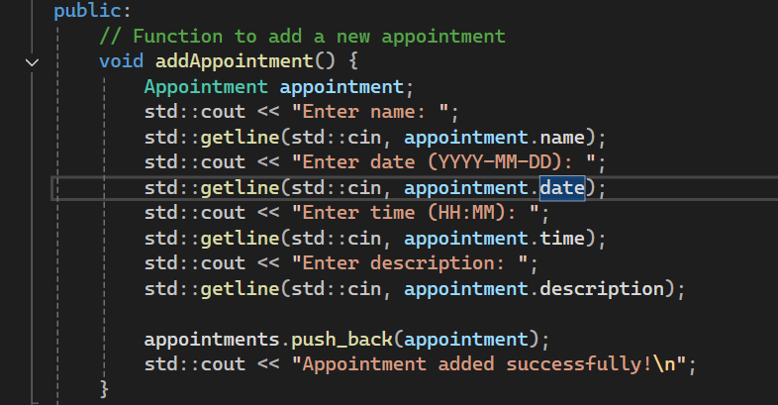

I restructured the function more structured.

